Module 01 Assignment

In module 01, you will prepare for ETL (Extracting, Transforming, and Loading) by learning the differences between sources and destination databases. After this module, you will understand more about the differences between Extracting from source data and Loading data into a destination. The assignment consists of the follow steps:

1. Read articles
2. Read chapters from your text book.
3. Review a design spreadsheet.
4. Create a Source and Destination database.
5. Create an ETL Script.
6. Write a Paper.
7. Submit your work to the Canvas site.

***This activity will take you about 2 to 4 hours, so plan accordingly!***

# Read aN Article

I have included several articles that covers common Business Intelligence, Data Warehousing, and ETL terminology and designs. Since one of our main goals is to perform ETL processing on a data warehouse, you will need to be familiar these. Please do not assume that you are using your experience or attendance in a previous class is enough. I still find these useful reviews after almost 20 years of working with databases and BI.

* 1-kimballgroup.com-The 10 Essential Rules of Dimensional Modeling
* 2-kimballgroup.com-Fables and Facts
* 3-kimballgroup.com-Design Tip 81 Fact Table Surrogate Key
* 4-kimballgroup.com-Six Key Decisions for ETL Architectures

# Read chapters from your text book

The textbook this quarter, **Delivering Business Intelligence with Microsoft SQL Server 2016 by Brian Larson**, contains a lot of information that is similar to that of the last quarter. While this will help with reading, it should not be assumed that you do not need to read chapters that you “already know.” The reason for this is that the author uses new/different terms and covers new/different features used in SQL Server BI solutions. So please plan on reading the first **84 pages** as a detailed review of materials covered previously.

* Chapter 1: Equipping the Organization for Effective Decision Making
* Chapter 2: Making the Most of What You've Got--Using Business Intelligence
* Chapter 3: Seeking for the Source--The Source of Business Intelligence
* Chapter 4: Two, Two, Two Model in One--The BI Semantic Model
* Chapter 5: First Steps--Beginning the Development of Business Intelligence

# Review the Instructor’s AdventureWorks design spreadsheet

I’ve provided you the spreadsheet called Mod1_BISolutionWorksheets.xlsx containing the design like the one in your text book. Please review this data warehouse design to understand the AdventureWorks Basics databases used in this class. My walk-through video will help you complete this task: [Reviewing the AdventureWorks Basics Spreadsheet](https://youtu.be/N4Cqv_k0gXs)

[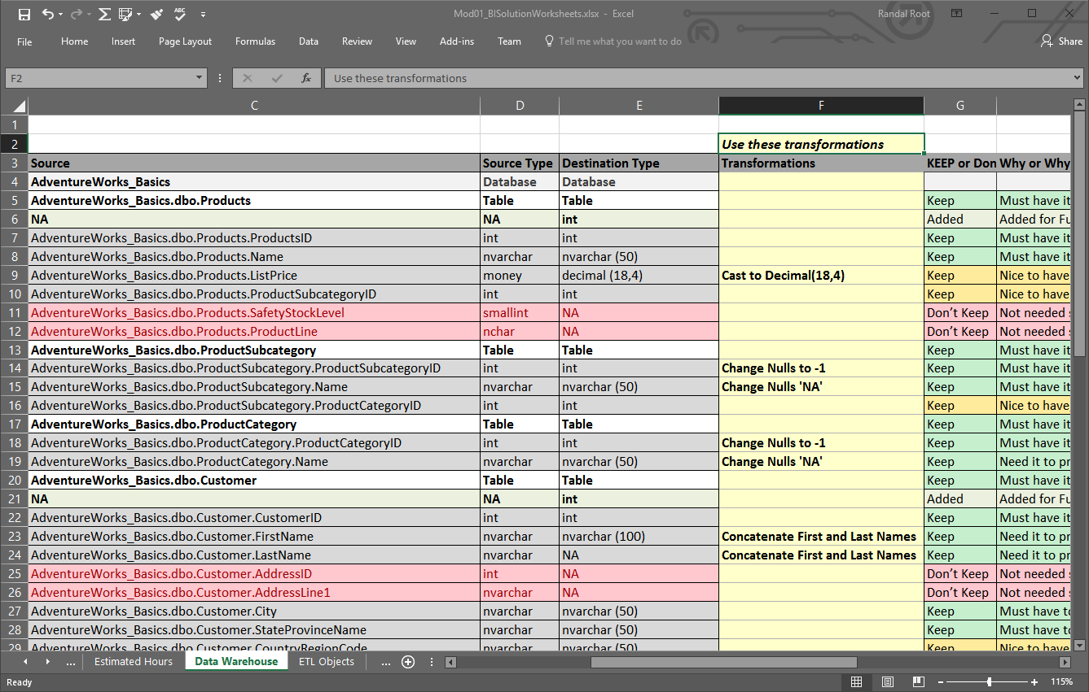](https://youtu.be/N4Cqv_k0gXs)

# Create the Source and Destination database

You now need to create both the source and destination databases for the AdventureWorks ETL project. You will do so using two different techniques; restoring a SQL backup and executing a SQL script.

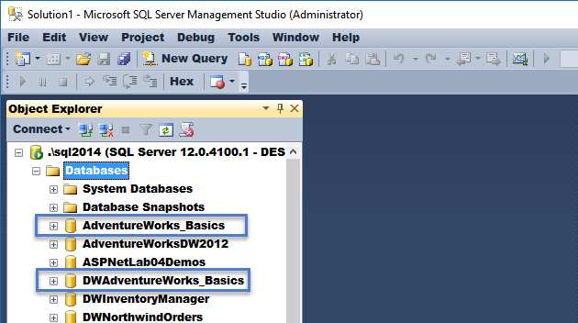

## Create the AdventureWorks Basics source database

I have created a script that will restore the AdventureWorks_Basics source database from a SQL Backup file. My walkthrough video will help you complete this task: [Restoring the AdventureWorks Basics Source Database](https://youtu.be/N1546ggB1rc)

## Create the DWAdventureWorks Basics data warehouse destination data<https://www.google.com/url?q=https%3A%2F%2Fyoutu.be%2FN1546ggB1rc>base

I’ve created a script that will generate the AdventureWorks data warehouse. Review the code and note how similar it is to what was in the book. My walkthrough video will help you complete this task: [Creating the DWAdventureWorks Basics Destination Database](https://youtu.be/HV7k3h7FdVU)

[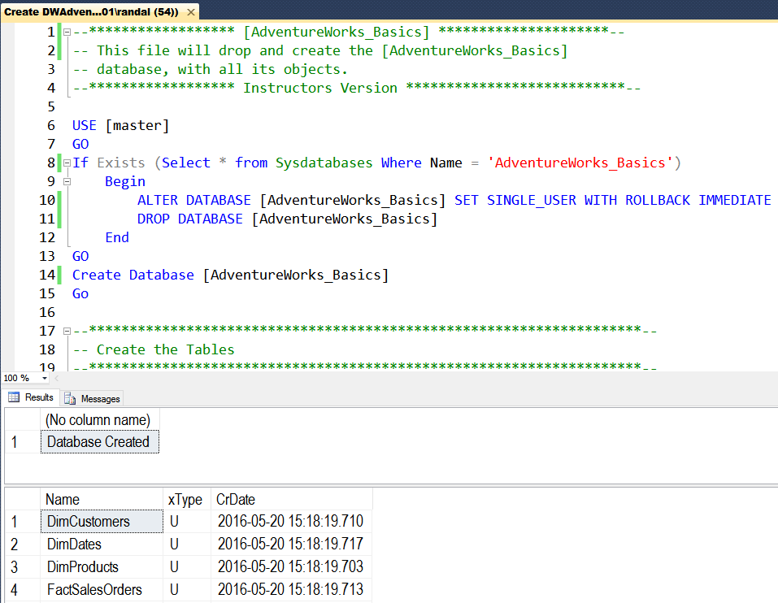](https://youtu.be/HV7k3h7FdVU)

# CREATE AN ETL ScripT

Now that you have the databases in place, you need to create an ETL script using SQL Coding. Make sure to use Views and Stored Procedures as we did in the class demos.

# Write a Paper

Create a Word document that outlines how your ETL Process works. This document should be written as a technical support document that new hire can read to understand what the process does and technicians might use to troubleshoot the process. Include screen shots, please. The document should be about 2 to 4 pages (including any pictures) in length. Please use Microsoft Word or something compatible for your paper. As you do so, capture screen-shots of these and place them in your Word document.

**NOTES:**

1) Create documentation and images like the ones found in this Web article: <http://www.developer.com/tech/article.php/3848981/The-7-Rules-for-Writing-World-Class-Technical-Documentation.htm>

2) If you need help getting screenshots see this page ( <http://m.wikihow.com/Take-a-Screenshot-in-Microsoft-Windows>).

3) Make sure you format it like a college paper instead of the text message. Things like having your name, date, class, and citations are always expected of a college student!

Please review this website for some examples: [http://jerz.setonhill.edu/writing/academic1/mla-style-papers/ (Links to an external site.)](http://jerz.setonhill.edu/writing/academic1/mla-style-papers/)

**Note**: Not putting your name, course, and date at the top of the document you will cost your 25% of your grade.

# Submit a Documnet to the Canvas site

After you have created your SQL ETL Processing Script file and the Word document, place them into one folder and ZIP that folder. Then upload the resulting ZIP file to the Canvas web site.

***You’re done!***